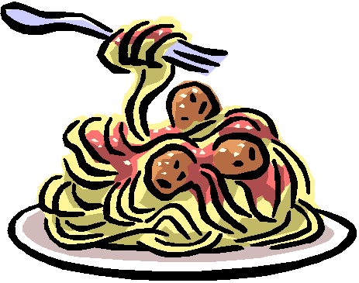
School Staff Spaghetti Supper 2021
This year we will be doing a drive through event
Thursday, March 18th from 4:30-7:00
Order your advanced tickets here for pickup behind the cafeteria. (Follow the arrows).
All orders will be the same size and price this year
$7.00 per person
Each order comes with spaghetti with meat sauce, breadstick, coleslaw, string cheese, and cookies for dessert.
We are hoping to do all sales in advance. You can place an order for tickets by returning the form below with your child or purchase in the district office. We will send tickets home with your child if you use this form.
All proceeds will go to scholarships for seniors from the class of 2021

Please send _________ tickets with my child
I have enclosed _$__________
Checks may be made payable to Lena Public Schools
Thank you for your support!

